

Currency
Converter

School: Computing
Academic year: 2023-2024
Submitted To : MR.Sathishkumar Ramar.MC
Name of the students : | C S Goutham Reddy | Register No : | 23102A030126
Course code & Title: | Object oriented programing Java-22AI1040002 | Section : | Section-1
program | B.Tech., | Branch | Data science
Semester : | IInd semester

ABSTRACT
The purpose of the Global Currency Converter is to provide a user-friendly graphical interface that allows users to easily convert amounts between different currencies. It aims to support a wide range of currencies, offering real-time conversion rates to ensure accuracy in financial planning, travel, business transactions, and educational purposes. context of globalization, where financial transactions and international travel have become commonplace, the need for an accurate, reliable, and easy-to-use currency conversion tool is more pronounced than ever. This project aims to address this need by delivering a software application that integrates real-time currency exchange rates for a wide range of global currencies, including cryptocurrencies.
Utilizing Java as the core programming language, the project leverages the robustness of Swing or JavaFX for the graphical user interface (GUI), ensuring a seamless and intuitive user experience. The application is designed to fetch live currency data from a reliable third-party API, providing users with the most current exchange rates available. Key features of the application include the ability to convert between multiple currencies, access a history of conversion queries, and save frequently used currency pairs as favorites for quick access.
The development process is structured into four main phases: requirement analysis and design, development, testing and deployment, and maintenance. Each phase is meticulously planned to ensure that the project meets its objectives of accuracy, reliability, and user satisfaction.
In conclusion, the Global Currency Converter project represents a practical tool aimed at individuals and businesses alike, facilitating effortless currency conversions with up-to-date information. By combining a straightforward user interface with powerful backend functionality, this project aspires to become an indispensable resource for anyone looking for quick and accurate currency conversions.

SYSTEM REQUIREMENTS
The hardware and software specification specifies the minimum hardware and software required to run the project. The hardware configuration specified below is not by any means the optimal hardware requirements. The software specification given below is just the minimum requirements, and the performance of the system may be slow on such system.
Hardware Requirements
- System : Pentium IV 2.4 GHz
- Hard Disk : 40 GB
- Floppy Drive : 1.44 MB
- Monitor : 15 VGA color
- Mouse : Logitech.
- Keyboard : 110 keys enhanced
- RAM : 256 MB
Software Requirements
- Operating System : Windows
- Language : Java
- JDK version :8+
- IDE :Eclipse or visual studio code

SAMPLE CODE :
import javax.swing.*;
import java.awt.*;
import java.awt.event.ActionEvent;
import java.awt.event.ActionListener;
import java.util.HashMap;
import java.util.Map;

public class CurrencyConverter extends JFrame {

private JComboBox<String> currencyFrom;
private JComboBox<String> currencyTo;
private JTextField amountField;
private JButton convertButton;
private JLabel resultLabel;

private Map<String, Double> exchangeRates;
public CurrencyConverter() {
setTitle("Global Currency Converter");
setSize(400, 200);
setLocationRelativeTo(null);
setDefaultCloseOperation(EXIT_ON_CLOSE);
setLayout(new GridLayout(5, 2, 10, 10));

initializeExchangeRates();
addComponents();
addEventHandlers();
}
private void initializeExchangeRates() {
exchangeRates = new HashMap<>();
exchangeRates.put("USD", 1.0);
exchangeRates.put("EUR", 0.9);
exchangeRates.put("GBP", 0.8);
exchangeRates.put("JPY", 130.0);
exchangeRates.put("AUD", 1.5);
exchangeRates.put("CAD", 1.3);
exchangeRates.put("CHF", 0.95);
exchangeRates.put("CNY", 6.8);
exchangeRates.put("INR", 80.0);
exchangeRates.put("SEK", 10.0);
}

private void addComponents() {
currencyFrom = new JComboBox<>(exchangeRates.keySet().toArray(new String[0]));
currencyTo = new JComboBox<>(exchangeRates.keySet().toArray(new String[0]));
amountField = new JTextField();
convertButton = new JButton("Convert");
resultLabel = new JLabel("Result will appear here");

add(new JLabel("From:"));
add(currencyFrom);
add(new JLabel("To:"));
add(currencyTo);
add(new JLabel("Amount:"));
add(amountField);
add(convertButton);
add(resultLabel);
}

private void addEventHandlers() {
convertButton.addActionListener(new ActionListener() {
@Override
public void actionPerformed(ActionEvent e) {
try {
String fromCurrency = (String) currencyFrom.getSelectedItem();
String toCurrency = (String) currencyTo.getSelectedItem();
double amount = Double.parseDouble(amountField.getText());
double result = convertCurrency(fromCurrency, toCurrency, amount);
resultLabel.setText(String.format("Result: %.2f %s", result , toCurrency));
} catch (NumberFormatException ex) {
JOptionPane.showMessageDialog(CurrencyConverter.this, "Please enter a valid amount","Error",JOptionPane.ERROR_MESSAGE);
}
}
}
);
}
private double convertCurrency(String from, String to, double amount) {
double rateFrom = exchangeRates.get(from);
double rateTo = exchangeRates.get(to);
return amount * (rateTo / rateFrom);
}
public static void main(String[] args) {
SwingUtilities.invokeLater(() ->{
new CurrencyConverter().setVisible(true);
}
);
}
}

SCREEN SHORT :

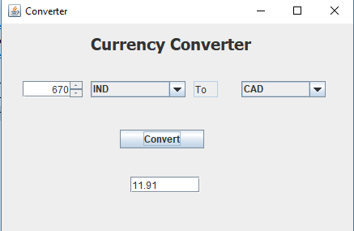

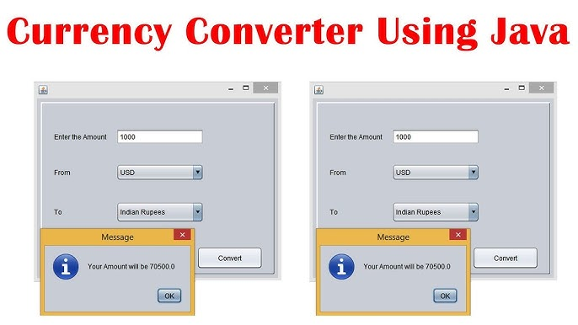

CONCLUSION
The Global Currency Converter aims to be a practical tool for anyone needing quick and accurate currency conversions. By focusing on user experience and leveraging real-time data, this application seeks to distinguish itself in its reliability and ease of use.
This document serves as a foundation for the project and will guide its development from conception to deployment, ensuring a structured approach to creating a valuable software tool.

